**DAILY ONLINE ACTIVITIES SUMMARY**

|  |  |  |  |  |  |  |  |  |
| --- | --- | --- | --- | --- | --- | --- | --- | --- |
| **Date:** | 21-05-2020 | | | | | **Name:** | K S Prajwal | |
| **Sem & Sec** | Vi A sec | | | | | **USN:** | 4AL18CS032 | |
| **Online Test Summary** | | | | | | | | |
| **Subject** | | MICROCONTROLLER AND EMBEDDED SYSTEMS | | | | | | |
| **Max. Marks** | | 30 | | **Score** | | | 17 | |
| **Certification Course Summary** | | | | | | | | |
| **Course** | Computer Vision Essentials | | | | | | | |
| **Certificate Provider** | | | Greatlearning.in | | **Duration** | | | **2 hr** |
| **Coding Challenges** | | | | | | | | |
| **Problem Statement: :** 1. To demonstrate the process of SRTF scheduling  2. To remove duplicate elements from a SLL | | | | | | | | |
| **Status:** completed | | | | | | | | |
| **Uploaded the report in Github** | | | | | yes | | | |
| **If yes Repository name** | | | | | <https://github.com/alvas-education-foundation/KS_Prajwal> | | | |
| **Uploaded the report in slack** | | | | | yes | | | |

Online Test Details: (Attach the snapshot and briefly write the report for the same)

Certification Course Details: (Attach the snapshot and briefly write the report for the same)

Coding Challenges Details: (Attach the snapshot and briefly write the report for the same)

**Online Test Details**: The online test was from module 1. There were 30 MCQ and the duration were 30 minutes. The questions were optimal. The score that I received was 15/30.

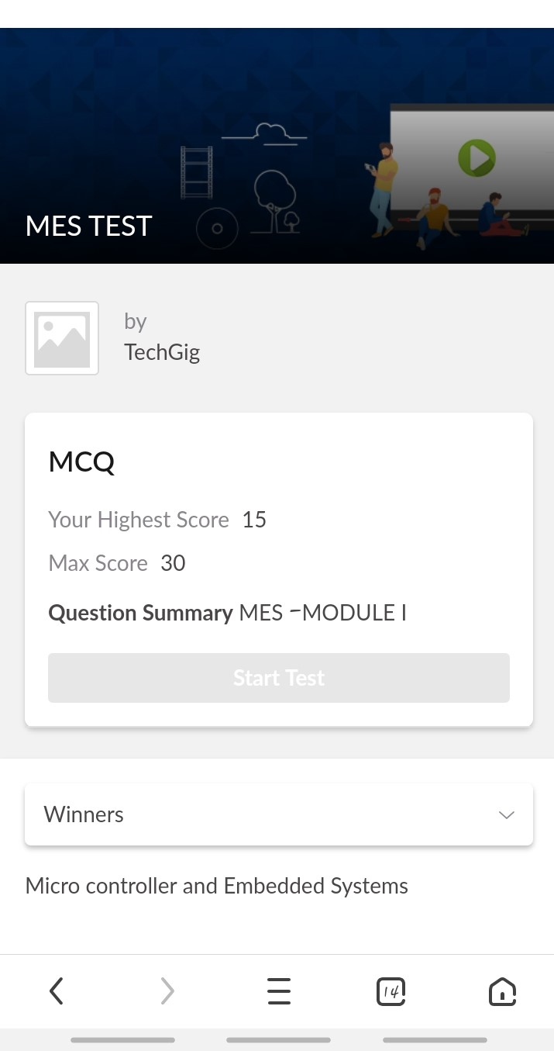**Snapshot**:

Snapshot of certification course:

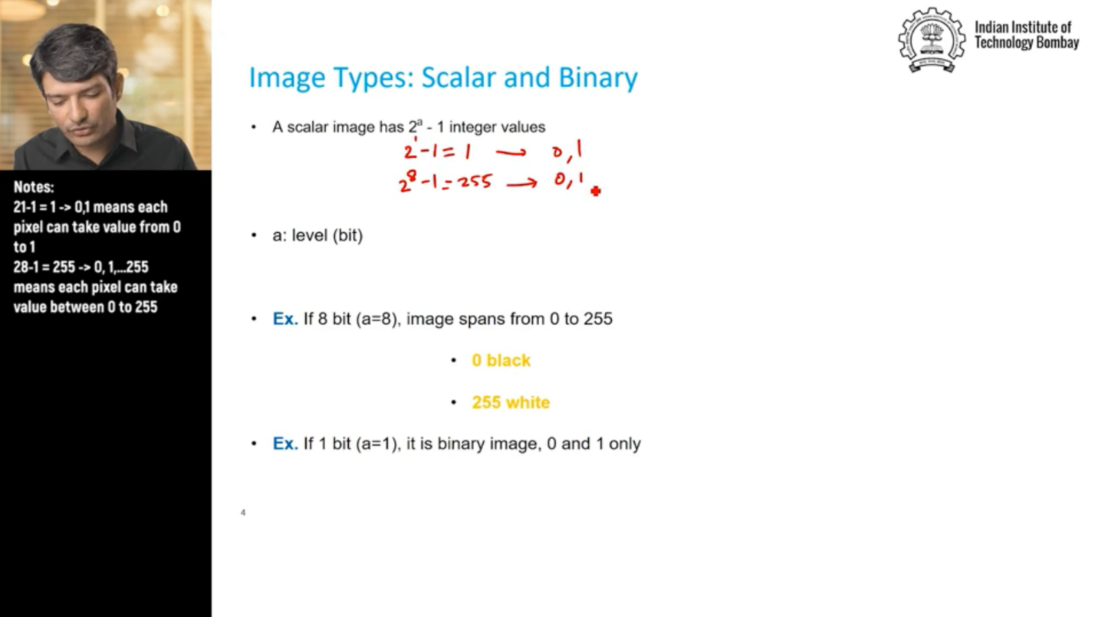

It was about the introduction to the course. The video was about the basics of images and working with it. the content covered were:

* Working with Images Introduction
* Looking at an image as a bunch of pixel values
* Types of images – Greyscale, Binary, colour
* Image formats – RAW, JPEG, PNG etc.
* Displaying images in python environment using PIL and Matplotlib

**Online coding:**

Problem 1: (using C language) Write a program to demonstrate SRTF(Shortest Remaining Time First) scheduling process.

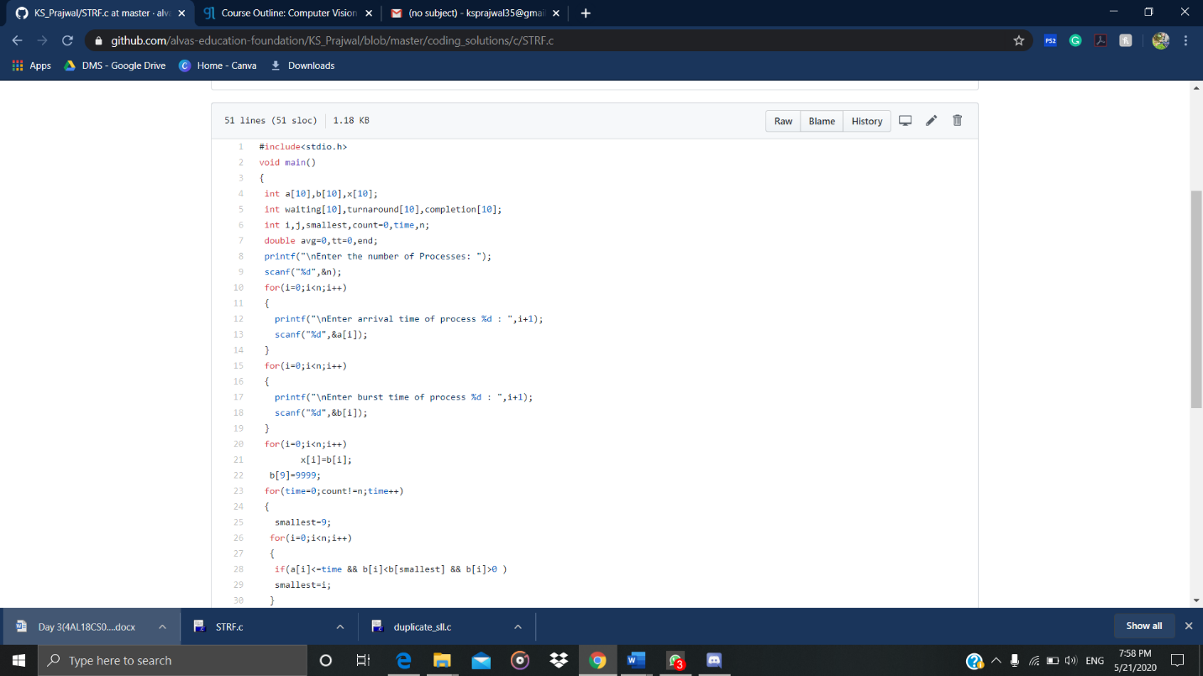

Problem 2: (Using C) Write a program to remove duplicate elements from a singly linked list

